Installation of Docker
First we connect the aws instance
Connect root user
- Sudo su
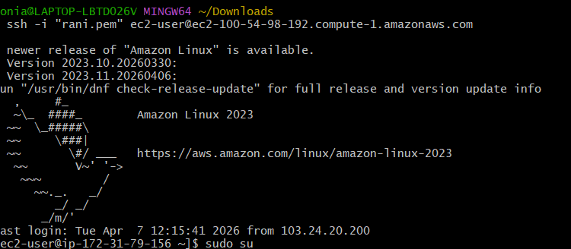
- Sudo yum update -y
- Sudo yum install docker -y
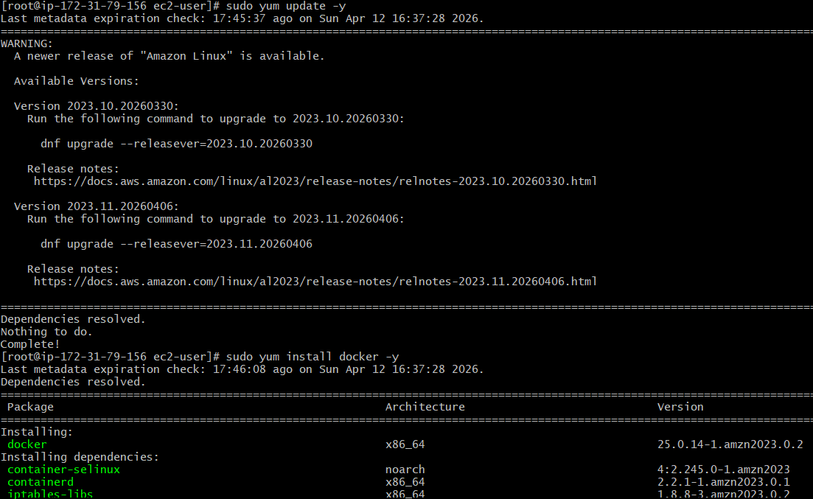
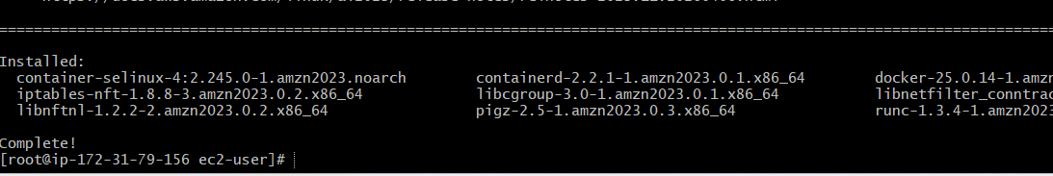
- Sudo systemctl enable docker
- Sudo systemctl start docker
- Sudo systemctl status docker
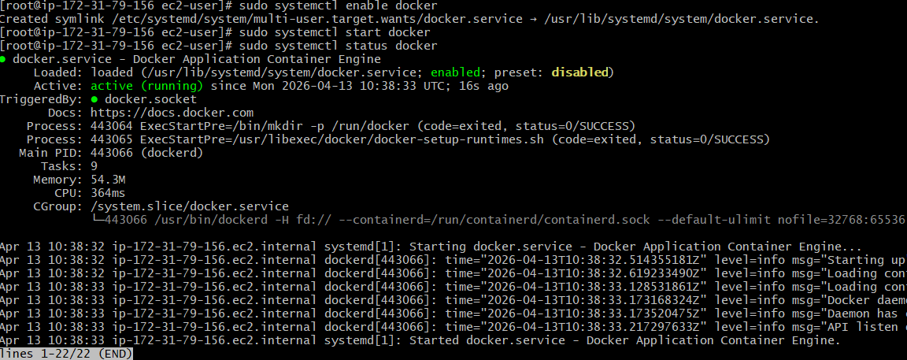

Installation of Jenkins
First we install java
- sudo yum install java-17-amazon-correto-y
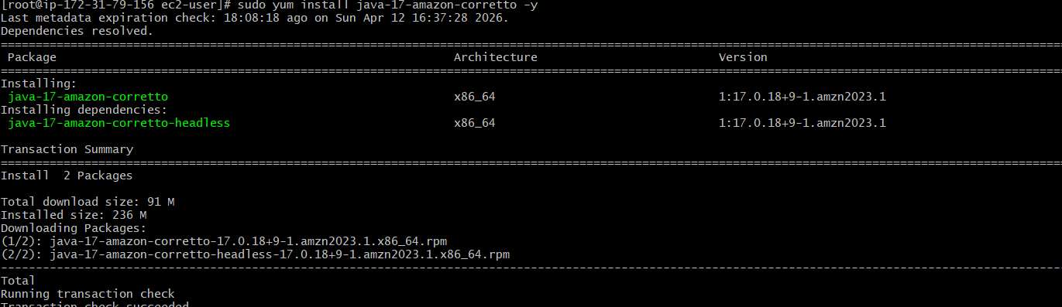
- sudo wget -O /etc/yum.repos.d/jenkins.repo \
https://pkg.jenkins.io/redhat-stable/jenkins.repo
- sudo rpm --import https://pkg.jenkins.io/redhat-stable/jenkins.io.key
- sudo yum update -y
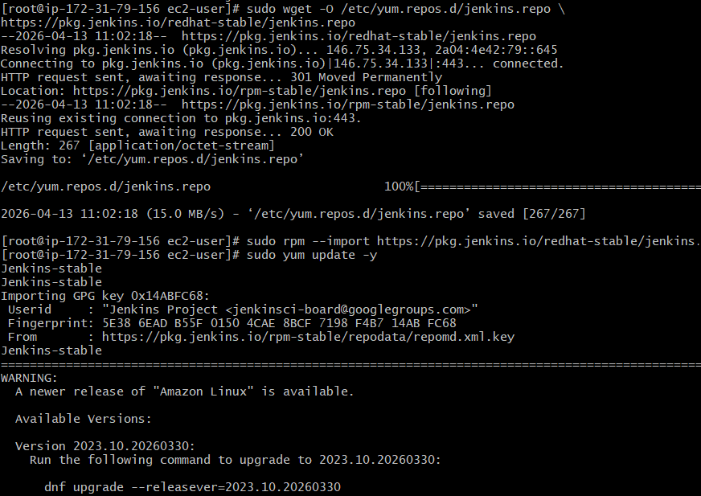
- sudo yum install Jenkins -y
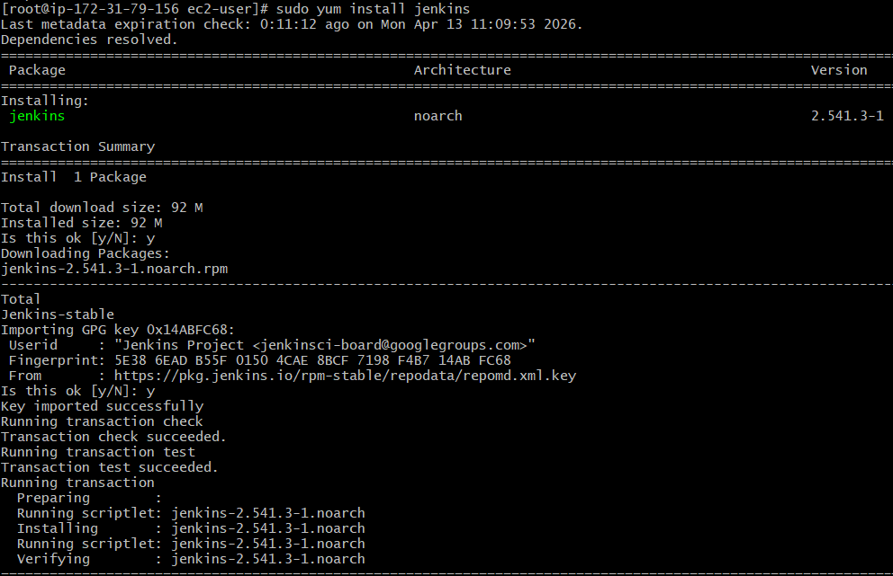
- sudo systemctl enable Jenkins
- sudo systemctl start Jenkins
- sudo systemctl status Jenkins
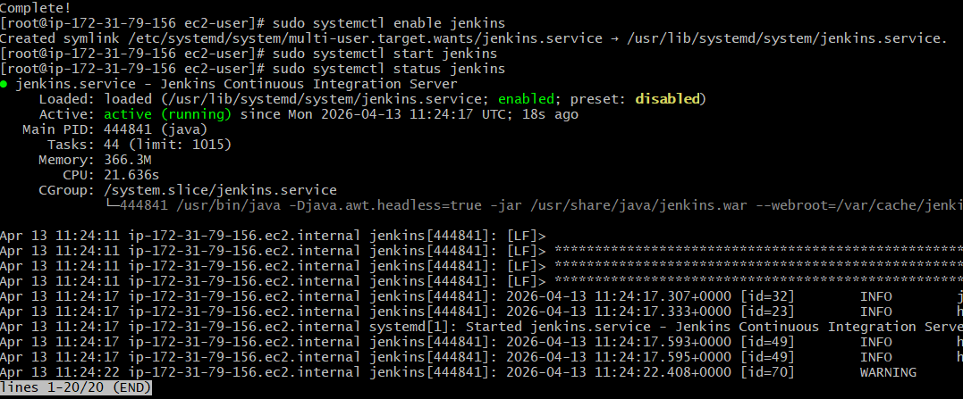

Open browser and copy the ip add then give the port number 8080
Well get the below pege
Give the cat command
Cat /var/lib/jenkins/secrets/initialAdminPassword

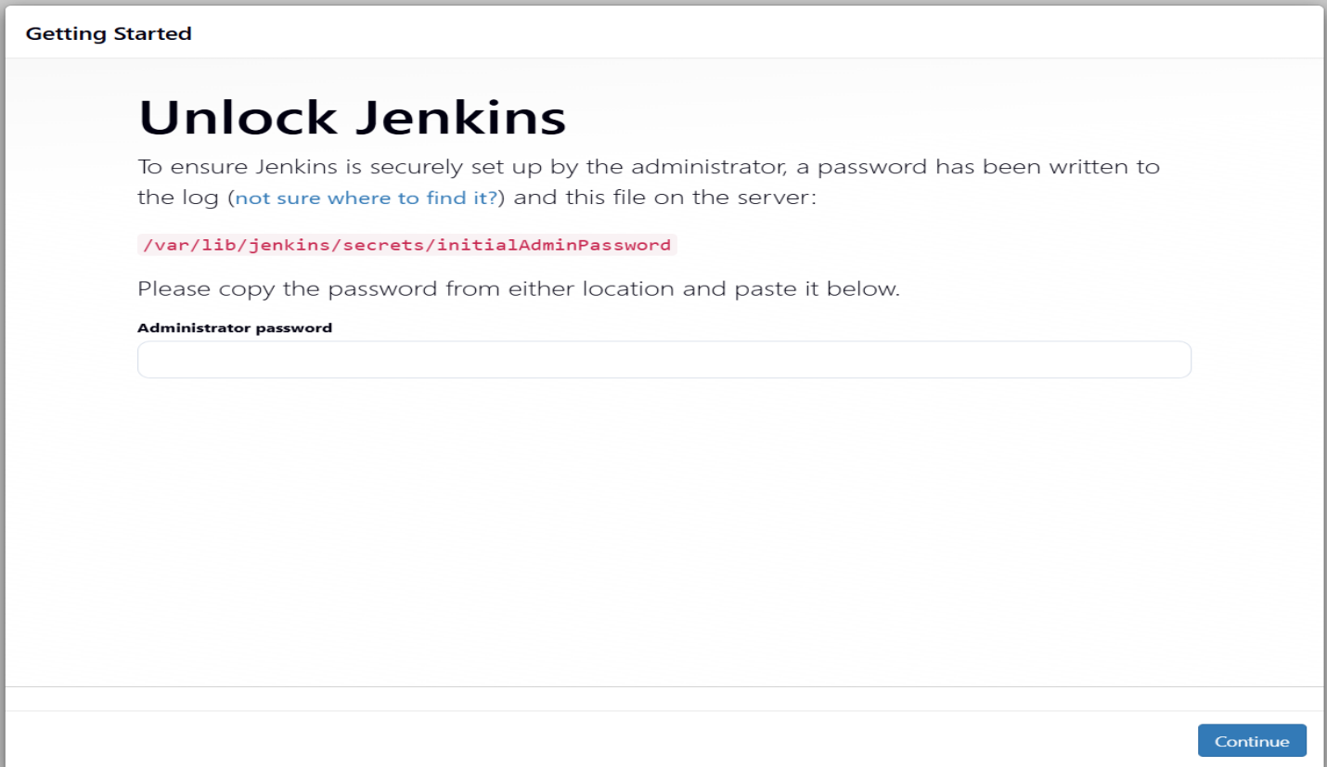
Then click on the install suggested plugins

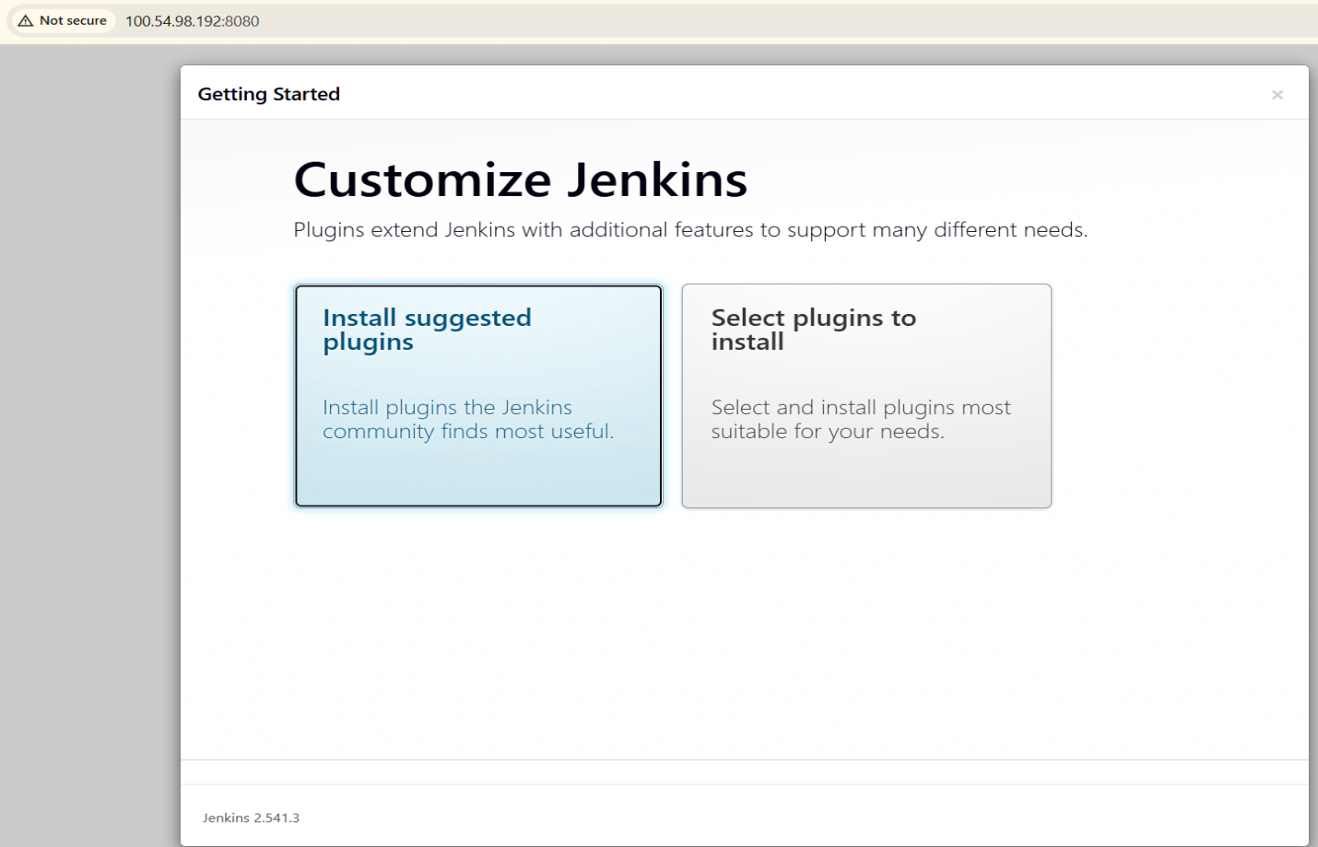
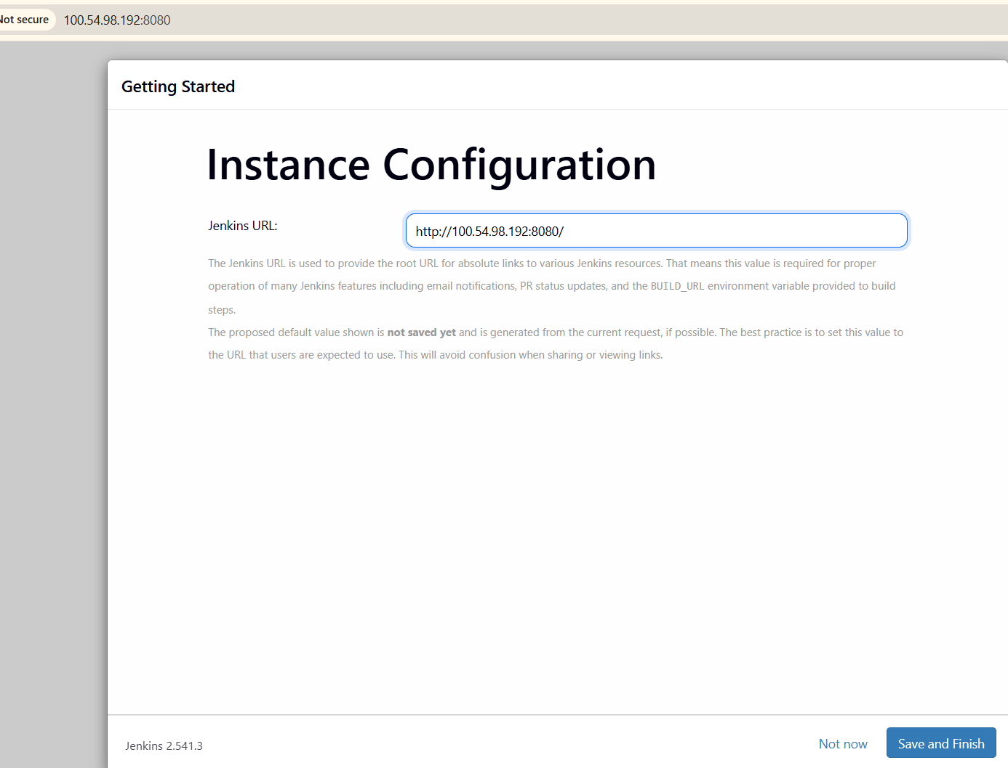
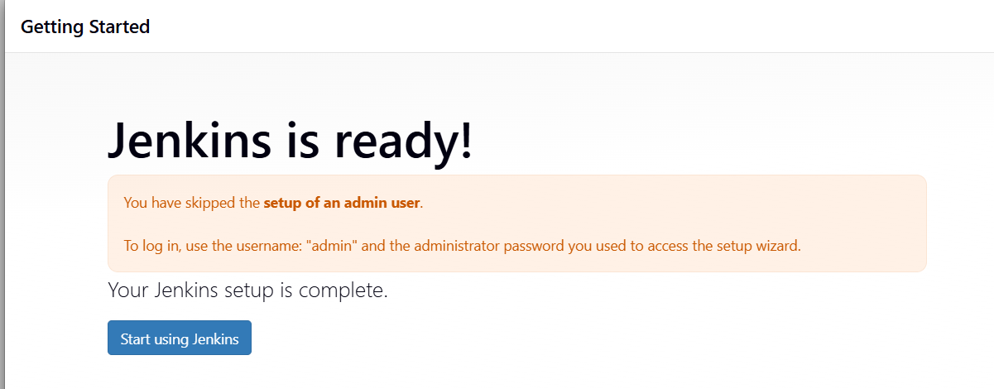

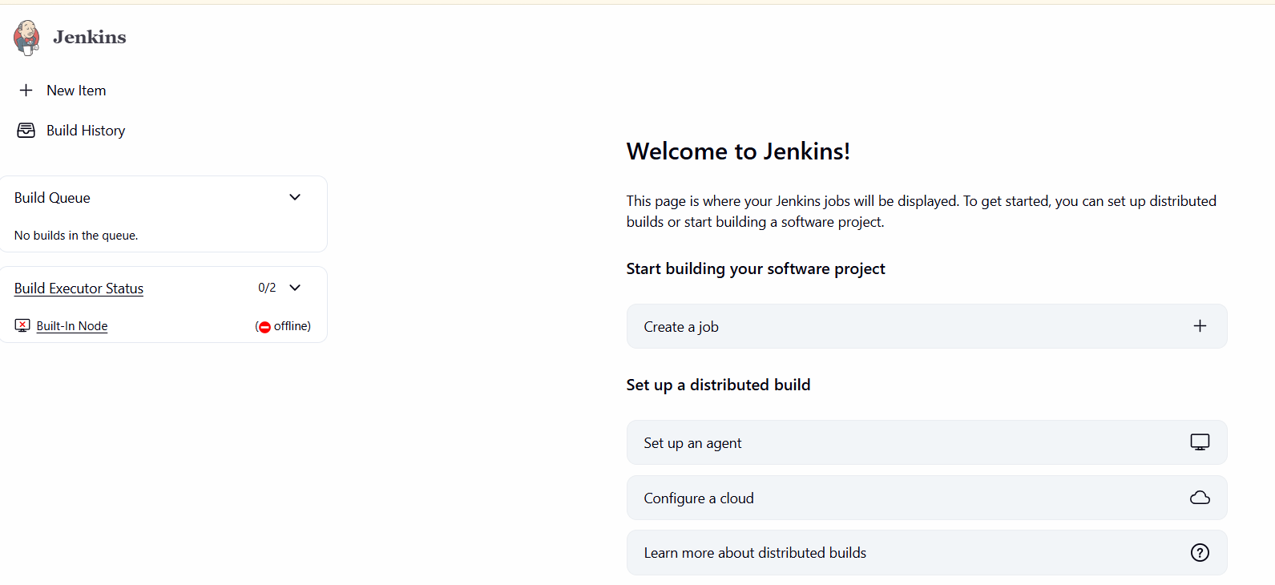
Installation of apache (httpd)
- sudo yum install httpd -y
- sudo systemctl enable httpd
- sudo sustemctl start httpd
- sudo systemctl status httpd

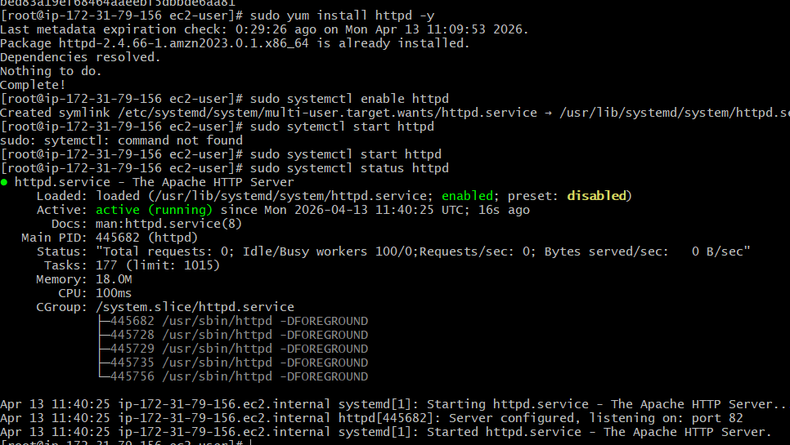
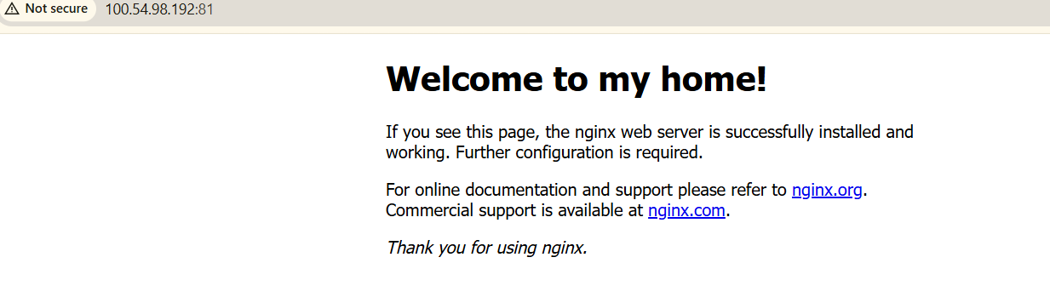

Installation of nginx
- sudo yum install nginx
- sudo systemctl enable nginx
- sudo systemctl start nginx
- sudo systemctl status nginx

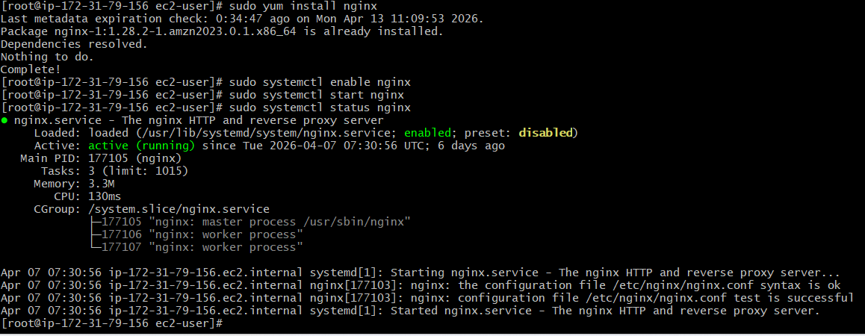

Installation of apache tomcat

wget https://dlcdn.apache.org/tomcat/tomcat-9/v9.0.117/bin/apache-tomcat-9.0.117.tar.gz
- ls
- tar xvf apache-tomcat-9.0.117.tar.gz

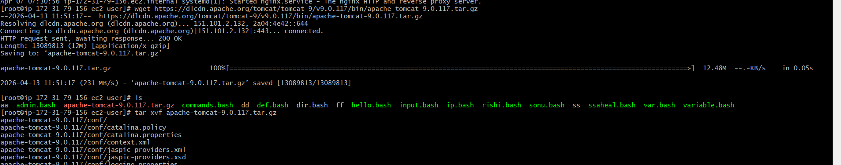
Ls
Rename the tomcat
- Mv apache-tomcat-9.0.117 tomcat
- Ls
- Cd bit/
- Ls
- Sh shutdown.sh
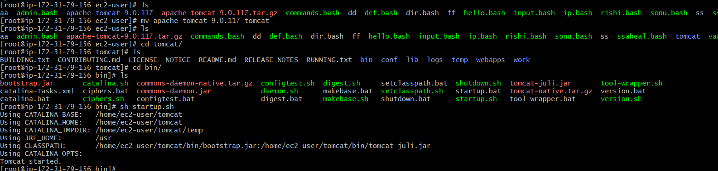
Cd ../conf/
Nano server.xml (we can change the port number)
Cd ../bin/
Sh shuydown.sh
Sh startup.sh
